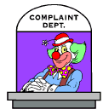
Booklet 1, Page 14 Ever had that phone call that asks if you can fill in a class because another teacher is absent or ill, AND they have not left you any lesson plans or work for the class!
Well this is WAR - What A Relief is your answer.
Here you will find pages of fun quizzes and activities, you can print out, then give the answers, Copy this to a thumb drive and you can cover any relief class, there are several sections. You can also download a quiz movie and power point quizzes from the link below.
http://www.peterfaulks.net/Teaching/HowTo/relief.html
Print out the question sheets individually the answers are at the end of this booklet.

Teacher to mark the quality (prizes)
14. Memory Drawing

Students sit back-to-back one student reads a description of a drawing, the other student draws the description on a plain A4 or half A4 sheet of paper. = Must be to scale and accuracy is important
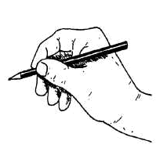

Here are the drawings pick one! Or make up your own
All are drawn half A4
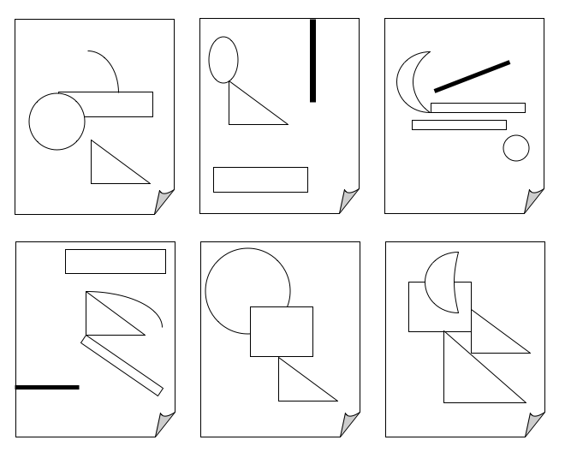
1
2
3
4
5
6

